Customer Shopping Behavior Analysis

Project Overview
This project analyzes customer shopping behavior using transactional retail data to uncover patterns in spending, customer segments, product performance, and subscription behavior.
The objective is to derive actionable business insights that can support decisions related to marketing strategy, customer retention, and product positioning.
The analysis combines Python (EDA & data cleaning), SQL (business queries), and Power BI (dashboard visualization) to simulate an end-to-end analytics workflow.

Dataset Summary
- Total Records: 3,900 transactions
- Total Columns: 18
Key Attributes:
- Customer Demographics: Age, Gender, Location, Subscription Status
- Purchase Details: Item Purchased, Category, Purchase Amount, Season, Size, Color
- Behavioral Data: Discount Applied, Promo Code Used, Previous Purchases, Purchase Frequency, Review Rating, Shipping Type
Data Quality Notes:
- Missing values were observed in the Review Rating column.
- Certain columns showed overlapping information and required validation.

Exploratory Data Analysis & Data Cleaning (Python)
Data preparation was performed using Python (pandas) to ensure consistency and analytical readiness.
Steps Performed:
- Data Loading: Imported dataset using pandas.
Key Columns:
- Age
- Gender
- Subscription Status
- Purchase Amount
- Item Purchased
- Category
- Review Rating
- Shipping Type

- Initial Exploration: Used df.info() and df.describe() to understand structure and distributions.
- Missing Value Handling:
  - Missing values in review_rating were imputed using the median rating per product category.
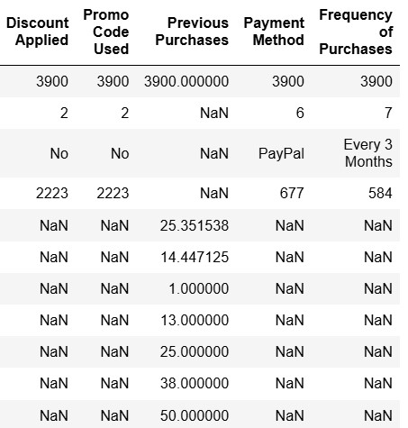
- Column Standardization:
  - Renamed columns to snake_case for readability and SQL compatibility.
- Feature Engineering:
  - Created age_group using quantile-based binning.
  - Derived purchase-related features for segmentation.
- Redundancy Check:
  - Identified overlap between discount_applied and promo_code_used.
  - Dropped promo_code_used to avoid duplication.
- Database Integration:
  - Loaded the cleaned dataset into PostgreSQL for further SQL-based analysis.

Business Analysis using SQL
Using PostgreSQL, multiple business-driven queries were executed to answer key analytical questions:
- Revenue by Gender – Compared total revenue contribution across genders.
- High-Spending Discount Users – Identified customers who used discounts but still spent above the average purchase value.
- Top 5 Products by Average Rating – Evaluated product quality perception using customer ratings.
- Shipping Type Comparison – Compared average purchase amounts between Standard and Express shipping.
- Subscription Analysis – Compared average spend and total revenue between subscribed and non-subscribed customers.
- Discount-Dependent Products – Identified products most frequently purchased with discounts.
- Customer Segmentation – Classified customers into New, Returning, and Loyal groups based on purchase history.
- Top Products per Category – Ranked top 3 most purchased products within each category using window functions.
- Repeat Buyers vs Subscription – Analyzed whether frequent buyers are more likely to subscribe.
- Revenue by Age Group – Evaluated revenue contribution across age segments.
These queries formed the foundation for dashboard visuals and insights.

4.1: SQL Queries & Outputs
The following SQL outputs were selected to highlight the most business-relevant findings that were later visualized in the dashboard.
- Key Insight : Subscription Impact
Subscription status shows minimal impact on average purchase value, indicating subscriptions may support retention rather than higher transaction size.
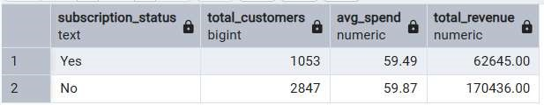

- Key Insight : Top Products per Category
Within each category, a small number of products account for the majority of purchases,indicating clear customer preferences and opportunities for focused product promotion.
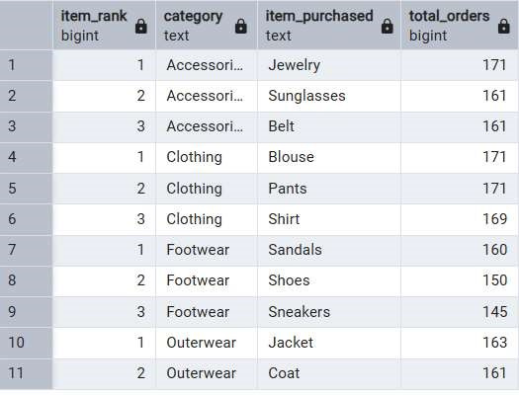
- Key Insight : Age-based Revenue Concentration
Customers aged 26–35 contribute the highest revenue, making them a priority segment for focused marketing strategies.
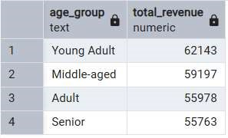

Power BI Dashboard
An interactive Power BI dashboard was created to visually communicate insights.
Dashboard Highlights:
- Revenue distribution across customer segments
- Subscription and purchase behavior comparison
- Product and category performance
- Age group contribution analysis
- Interactive slicers for better exploration
The dashboard focuses on clarity, minimal visuals, and business relevance rather than excessive charts.

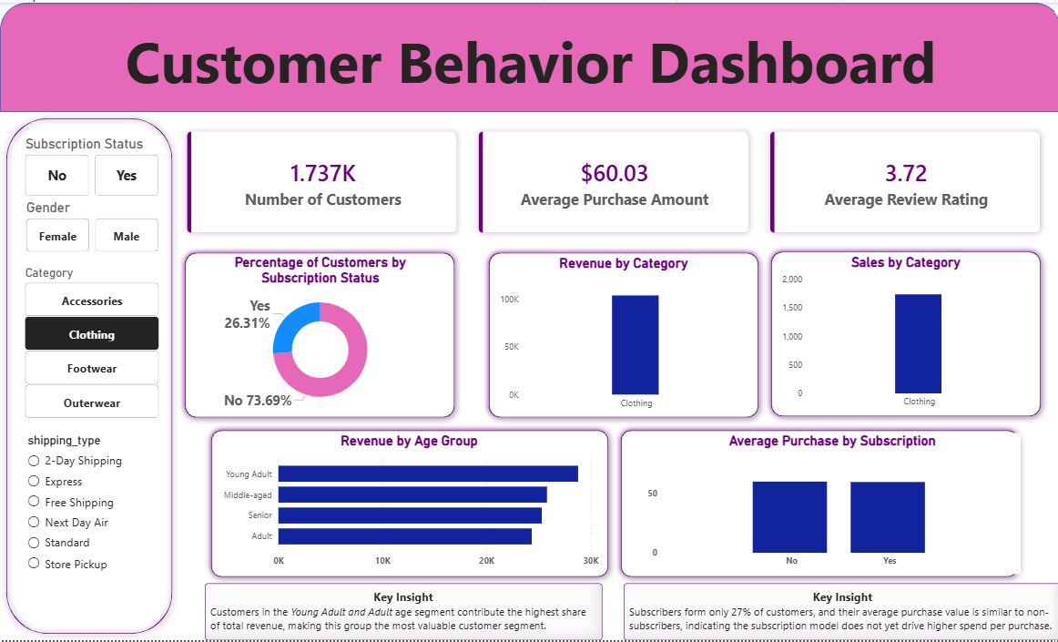

Business Recommendations
- Optimize Subscription Strategy: Focus on long-term engagement benefits rather than shortterm revenue lift.
- Strengthen Loyalty Programs: Incentivize repeat buyers to transition into loyal customers.
- Product Promotion: Highlight top-rated and frequently purchased products in campaigns.
- Targeted Marketing: Allocate marketing efforts based on age-group revenue contribution.

Tools & Technologies Used
- Python: pandas, numpy
- SQL: PostgreSQL
- Visualization: Power BI
- Version Control: Git & GitHub

